AFFILIATED TO KENT FA
AN FA CHARTER STANDARD CLUB
All correspondence to Youth secretary Mark Wilson
Email: spartans@rochesterunited.co.uk Web Page: www.rochesterunited.co.uk

MATCH DAY DETAILS
UXX: ROCHESTER UNITED FC v xxxxx  MANAGER : xxxxx  DATE: SUNDAY xxxxxx 202X  KICK OFF: xxxxx  PITCH : X aside  REFEREE: XXXXX | 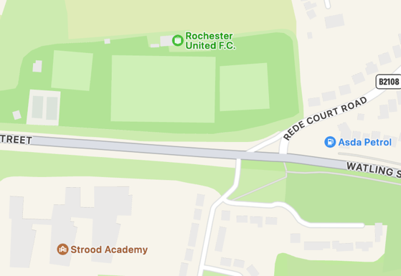

ROCHESTER UTILITIES STADIUM, REDE COURT ROAD, STROOD, ROCHESTER ME2 3TU

WE PLAY IN RED SHIRTS, BLACK SHORTS & BLACK SOCKS, GOALKEEPER IN xxxxxxx

THERE IS LIMITED PARKING AT THE GROUND FOR PLAYERS AND SUPPORTERS, WHEN FULL PLEASE PARK ON STREETS OUTSIDE AND RESPECT OUR NEIGHBOURS
FOR GROUND ENTRY PLEASE USE THE ENTRANCE OPPOSITE THE ASDA GARAGE
THE BOWLS ENTRANCE OFF OF WATLING STREET IS NOT TO BE USED AT ANY TIME
TOILETS ARE AVAILABLE AT THE GROUND
NO SMOKING OR VAPING
DOGS ARE NOT PERMITTED
CHILDREN MUST BE SUPERVISED AT ALL TIMES ANY DAMAGES TO CLUB PROPERTY WILL BE CHARGED

